# 第九次練習 function

-- 找出年訂購最多的書籍名稱

use pubs

CREATE FUNCTION GetToptitle

(@year char(5))

RETURNS char(80)

BEGIN

DECLARE @name char(80)

SELECT TOP 1 @name=title

FROM sales JOIN titles

ON sales.title_id = titles.title_id

WHERE DATEPART (YYYY, ord_date) = @year

GROUP BY title

ORDER BY SUM(qty) DESC

IF @@ROWCOUNT = 0

RETURN 0

RETURN @name

END

GO

--使用

SELECT dbo.GetToptitle('1993') AS '書籍'

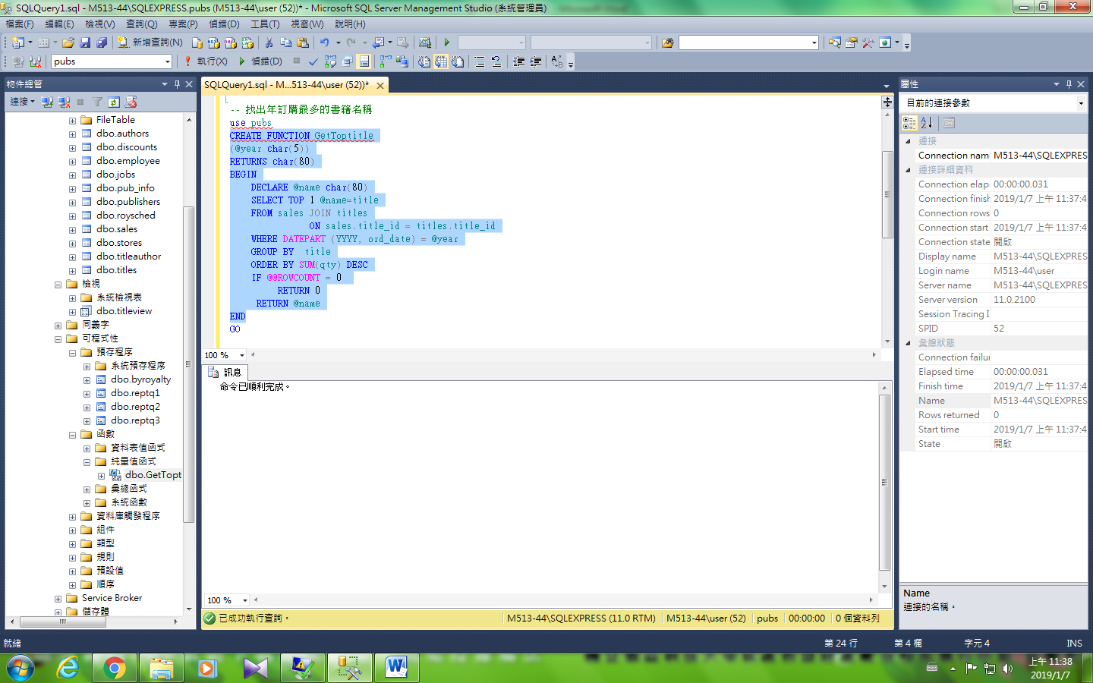

## WHILE 迴圈

DECLARE @site_value INT;

SET @site_value = 1992;

WHILE @site_value <= 1995

BEGIN

select [dbo].[GetToptitle](@site_value) as '書籍'

SET @site_value = @site_value + 1;

END;

